LYN_CSR_01 November 2014 10
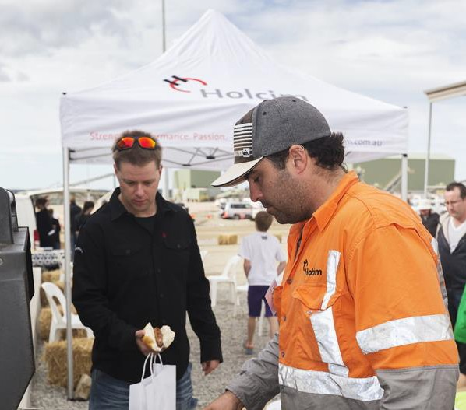

Strength. Performance. Passion.

Lynwood Quarry Community Investment Fund

Application form

2015 to 2019

1. Overview

The Community Investment Fund dedicated to the Marulan and surrounding communities is designed to help improve the quality of life of the members of our workforce, their families and the communities. We value local needs, promote community involvement and partner with local stakeholders around our operations. Holcim has dedicated funding and co-contributions to improve economic, cultural and social development throughout the region. In addition as a part of the community we encourage and support our employees’ engagement in volunteering and local community work.

2. Contact

If you have any questions regarding the fund, please contact the Environment and
Community Liaison on 1300 657 051 or lynwoodcif-aush@holcim.com

3. Funding Application Form

Project Contact Details

Primary Contact
Name: ________________________________
Position:_______________________________
Phone:________________________________
Fax:__________________________________
Email:_________________________________
Address:_______________________________

Secondary Contact

Name: ________________________________
Position:_______________________________
Phone:________________________________
Fax:__________________________________
Email:_________________________________
Address:_______________________________

Organisation details: (must be incorporated)

Organisation name:_____________________
ABN/ICN: _____________________________
Insurance policy number:_________________ Insurance company:______________
Level of insurance:______________________

Project Details:

Project Name:__________________________________________________________

Location (attach map if available): (must be within 20km of Lynwood Quarry) __________________________________________________________________________________________________________________________________________

Project Overview:

Please briefly describe the project (What are you planning to do)

__________________________________________________________________________________________________________________________________________
__________________________________________________________________________________________________________________________________________
__________________________________________________________________________________________________________________________________________
__________________________________________________________________________________________________________________________________________

Please briefly describe the project objectives: (what will the project achieve)
__________________________________________________________________________________________________________________________________________
__________________________________________________________________________________________________________________________________________

Please briefly outline the milestones that will lead to project completion. Please ensure dates are included for each milestone.

Milestone 1:
__________________________________________________________________________________________________________________________________________

Milestone 2:
__________________________________________________________________________________________________________________________________________
Milestone 3:
__________________________________________________________________________________________________________________________________________
Milestone 4:
__________________________________________________________________________________________________________________________________________
(Add milestones as required)

Criteria for applications

Please provide information detailing how the project addresses the following criteria. Please insert additional lines if required. Note – Projects are assessed on the applicants responses to the below criteria. Not providing adequate information reduces the chances of a successful project.

CR1: The project must address at least one of the following criteria but can also address multiple. Please provide specific detail on how the project addresses the criteria pertinent to the project.

Providing education for society's future includes projects related to educational activities for the wider community.

__________________________________________________________________________________________________________________________________________
__________________________________________________________________________________________________________________________________________
__________________________________________________________________________________________________________________________________________
Supporting sustainable community development includes projects related to community development activities in collaboration with local community members and often NGOs – these include projects/activities raising the quality of life and building capacity for less privileged community members.

__________________________________________________________________________________________________________________________________________
__________________________________________________________________________________________________________________________________________
__________________________________________________________________________________________________________________________________________

Building infrastructure for liveable communities includes all spending related to the provision of liveable communities and promotion of civic engagement such as housing, transportation, sanitation, roads, bridges, canals, and recreation for community members.

__________________________________________________________________________________________________________________________________________
__________________________________________________________________________________________________________________________________________
__________________________________________________________________________________________________________________________________________

CR2: Support the sustainability of social, environmental and/or economic diversity, expansion or resilience of the region.

__________________________________________________________________________________________________________________________________________
__________________________________________________________________________________________________________________________________________
__________________________________________________________________________________________________________________________________________

CR3: Create opportunities for Holcim to actively be involved and help promote the project/activity.

__________________________________________________________________________________________________________________________________________
__________________________________________________________________________________________________________________________________________
__________________________________________________________________________________________________________________________________________

In addition:

CR4a: For submissions greater than $2 000 please detail applications for any other funds or contributions from other organisations (including government and non-government) or community members.

__________________________________________________________________________________________________________________________________________
__________________________________________________________________________________________________________________________________________
__________________________________________________________________________________________________________________________________________

CR4b: For submissions greater than $5 000 please also discuss the improved social, cultural or environmental outcomes expected.
__________________________________________________________________________________________________________________________________________
__________________________________________________________________________________________________________________________________________
__________________________________________________________________________________________________________________________________________

Detailed Budget

Please provide a budget in the below table for all aspects of the project.

 |  |  |  | Holcim |  | Other
Item | Cost | Qty | Total | Cash | In-kind | Cash | In-kind
Example:  Star pickets | $1.85 | 50 | $92.50 | $50.00 | 0 | $42.50 | 0
Total

Budget explanation

Please provide any explanation required to provide sufficient details regarding the budget. This should include details of non Holcim in-kind and cash contribution and whether they are already secured.

__________________________________________________________________________________________________________________________________________
__________________________________________________________________________________________________________________________________________
__________________________________________________________________________________________________________________________________________

Other information

Please explain in detail how the project will promote Holcim and our contribution to the project:

__________________________________________________________________________________________________________________________________________
__________________________________________________________________________________________________________________________________________
__________________________________________________________________________________________________________________________________________

Please provide any information pertinent to return on investment considerations or value for money:

__________________________________________________________________________________________________________________________________________
__________________________________________________________________________________________________________________________________________
__________________________________________________________________________________________________________________________________________

Please include any other information pertinent to the project:

__________________________________________________________________________________________________________________________________________
__________________________________________________________________________________________________________________________________________
__________________________________________________________________________________________________________________________________________

